Find Assignment

Mandatory:

1. Search and display all \*.c and \*.h files in all subdirectories starting from current directory

🡺 find. : Starts the each search from the current directory, -name “\*.c” -o -name “\*.h” are for searches for files ending with .c or .h.

🡺 “find . -type f \( -name "\*.c" -o -name "\*.h" \)”

2. Search and display all directories in all subdirectories starting from current directory

🡺 -type d: Specifies that only directories should be displayed.

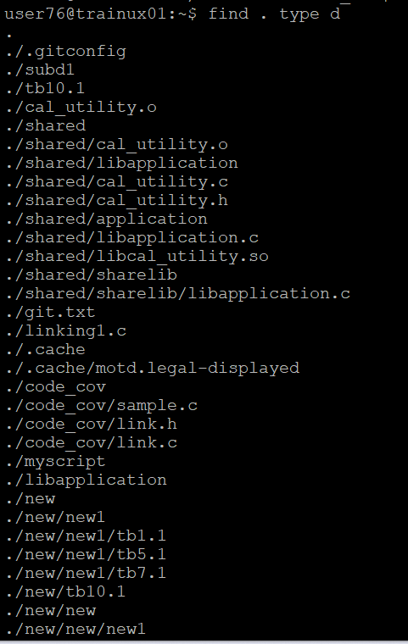

3. Search and display all files with permissions only rw with user and execute permission for others

🡺 find. : for search of current directory. -type f: limits the search of files. -perm 0701 for matches files with rw-------x permission and -prem 0705 matches files with rw-r-----x permission

